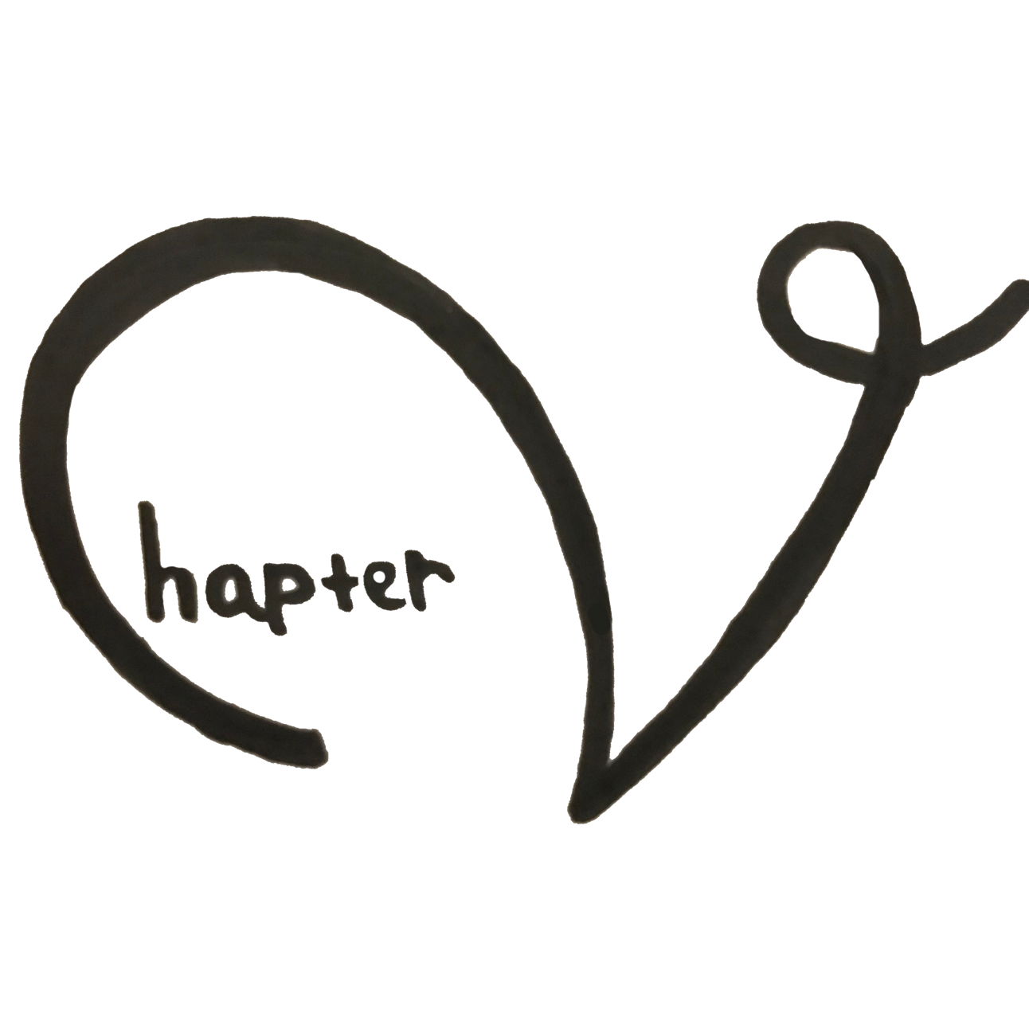

|  |  |  |
| --- | --- | --- |
| **Players**: 4 - 6 | **Type**: Semi-Digital | **Time**: 2 hour |

**Object of the Game**

Visualize hard-to-draw topics and gain new knowledge about learning science. Guess the others’ drawing and debate about your own drawing to gain additional points!

**Game Field**

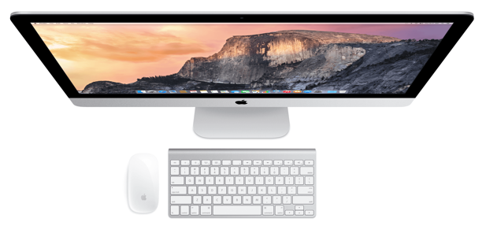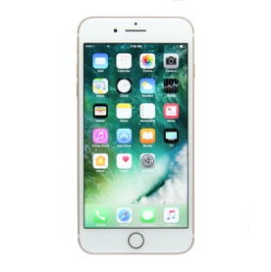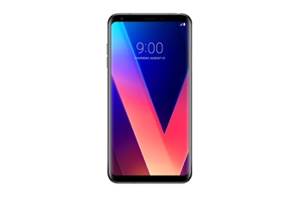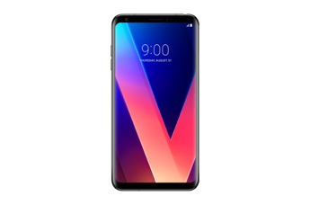

Voting tokens

paper

paper

paper

paper

**Contents**

This game uses:

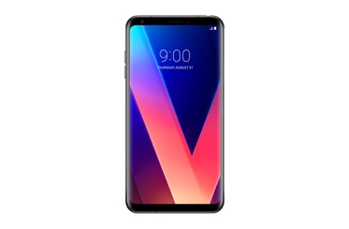



papers and pens for each player

7 tokens with letter A-G, different player gets different color

1 phone **for each player**. It can be of any brand as long as it can connects to Wi-Fi

Wi-Fi

1 laptop/PC

**Rules**

1. **Set up the local server** and open the game on the PC/laptop; this device will serve as your **‘screen’**. Detailed instruction on how to set this up can be seen  **HERE (TBA)**
2. **At your smartphone,** **go to airconsole.com** or open the AirConsole app. Follow the instruction there to input the number code available at the screen to your phone. The code can be seen at the top right of the screen.
3. **Prepare the paper, pens, and tokens** for every player. Make sure that each player get 7 tokens, and different players have different color.
4. **Make sure that all players are connected** and each smartphone display the menu below. Once all players are connected, one of the players can **press start**.

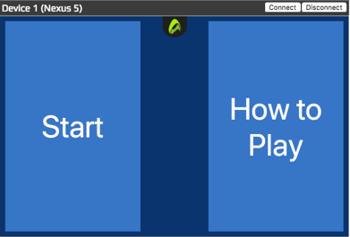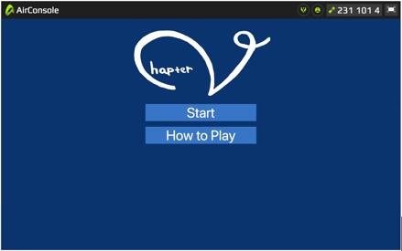

Smartphone Display

Screen Display

1. **Draw the topic** displayed in your phone within the time showed on the screen. Each player will receive different topic.

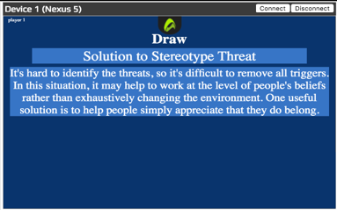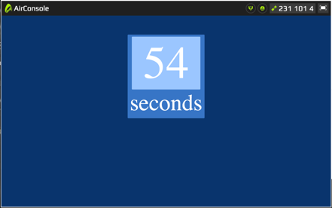

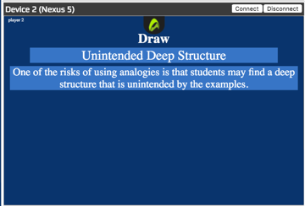

Screen Display

Smartphone Display

1. **Put all the drawings to the center of the table**, and then using each token, **match the drawings to the topic**. **The letter for each topic can be seen at the screen**. Put your answer/token face down on all the drawings, including yours. Take note that the screen will display all players’ topic + 1 fake topic.

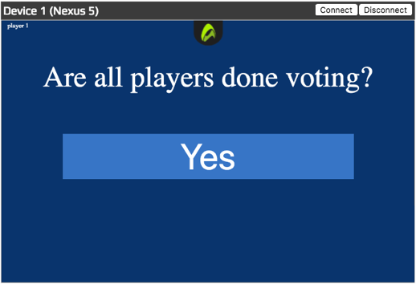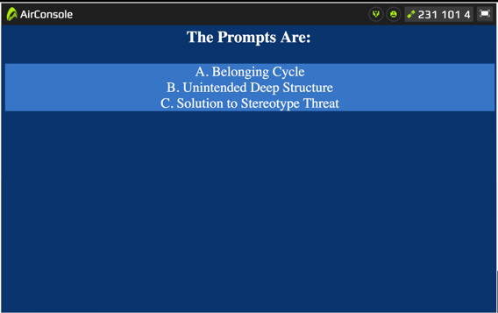

Screen Display

Smartphone Display

1. 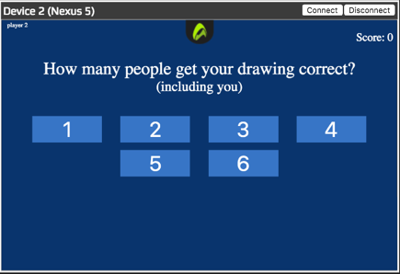The screen then will display the topic and the description one by one. **Player whose topic is displayed at the screen have to reveal which drawing is theirs, and flip all the tokens on the drawing to reveal the answers.** This player then can input how many players got their drawings correct, while the others can input whether they guess correctly or not.

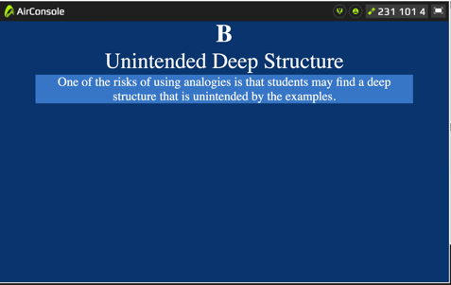

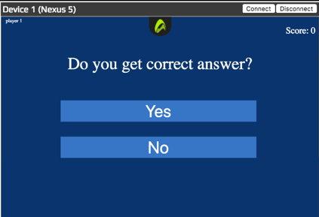

Screen Display

Smartphone Display

1. 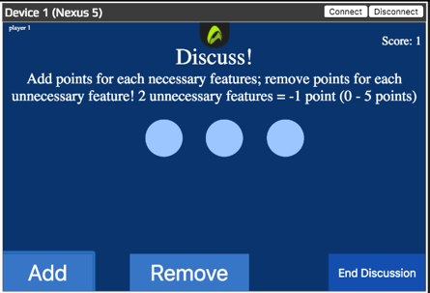Bonus round: **the person whose topic is displayed on the screen have to argue which part of their drawing is an important feature for the topic**. An important feature can be: a part that describe the topic well, a part that is very closely related to the topic, etc. For each important feature, player can add 1 point. **Other people can also argue whether some parts in the drawing is important or not.** For every 2 unnecessary features, player can remove a point. After all player finish the discussion, one player can press the “End Discussion” button.

Smartphone Display

1. This **game ends** when at least a player get **≥ 45 points**.

**FAQ**

|  |  |
| --- | --- |
| Can we write words in the drawing? | No. Players, however, are allowed to put in characters not included in alphabet. Ex: ‘+’, ‘-‘, ‘=’, ‘?’, etc. |
| I’m not familiar with the topic. What should I do? | Make sure that you’re playing “Chapter V: Begin” version instead of “Re: Chapter V”. There should be a description of the topics during the drawing process, and the time limit for the drawing is 1 minute. |
| Do I have to put tokens in all drawings? | Yes. Make sure you try to guess all the drawings before continuing the game. |
| Do I put my answer on my own drawing? | Yes. All player have to put tokens on all drawings, including the drawings they each made. |

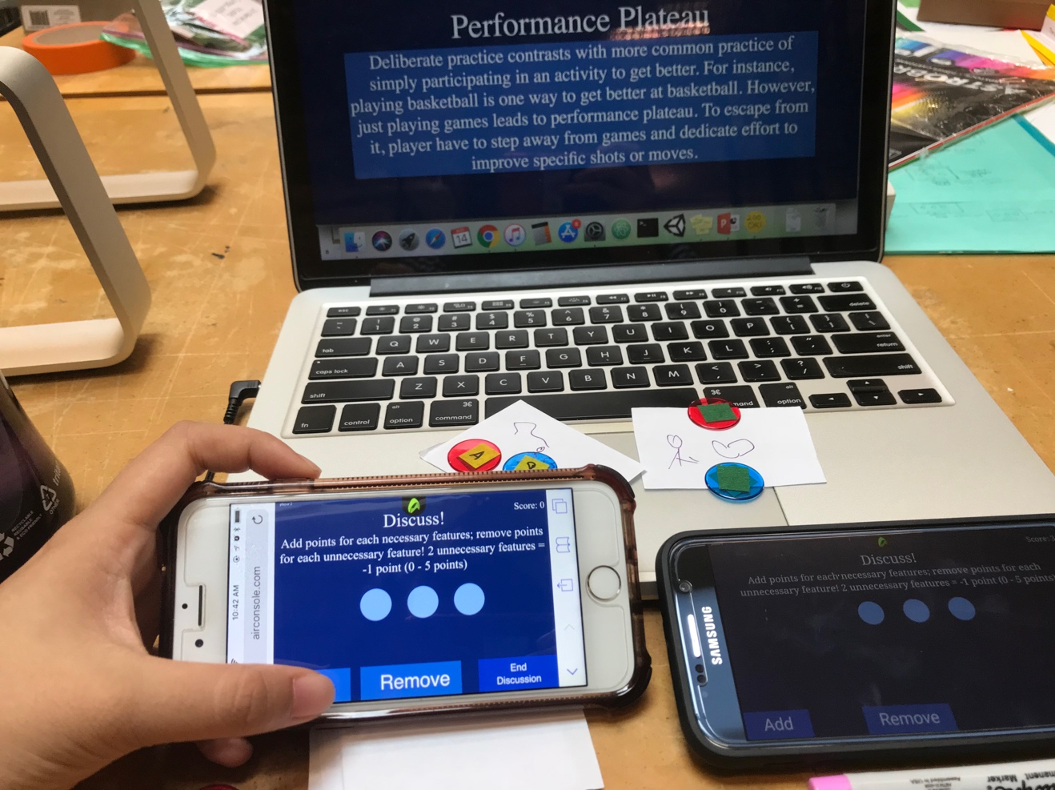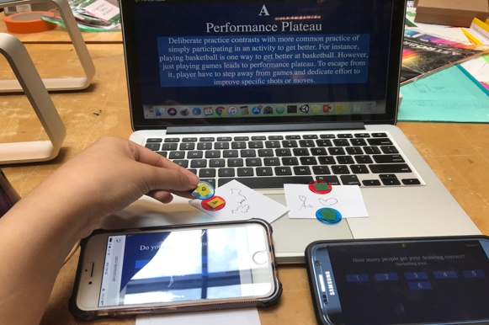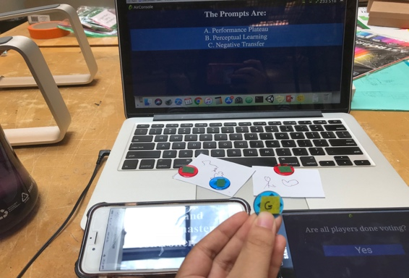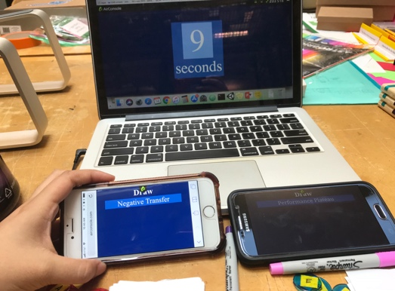**Example of One Round**

**Match** the prompts with the drawings

**Discuss** whether each feature of the drawing is necessary/unnecessary.

Example:

A: “The hand in the drawing is necessary because it’s the main focus in Hands-On Making” (+1 chip)

B: “But I think, this apple drawing is unnecessary because it’s unrelated to the topic and the description” (-1 chip)

Etc.

**Reveal** the answers and **Learn** the topics

**Draw** the topic!